Morgan Academy is the first school in Dundee to provide laptops for every pupil
By Debbie Clarke
Dundee Courier - October 8 2022, 5.59am
Kaja Przepiora, Indea Adeyosoye and Beth Skelly using their new laptops at Morgan Academy. Image: Mhairi Edwards/DCThomson.

Morgan Academy is the first school in Dundee to give every pupil their own laptop.
The school is introducing a 1-1 digital device programme ahead of a Scottish Government target of a device for every schoolchild by 2026.
Some other Scottish secondary schools – including Brechin High School and Bertha Park High School – have already issued laptops or tablets to every pupil, but Morgan Academy is the first school in the city to deliver such an approach to digital inclusion.
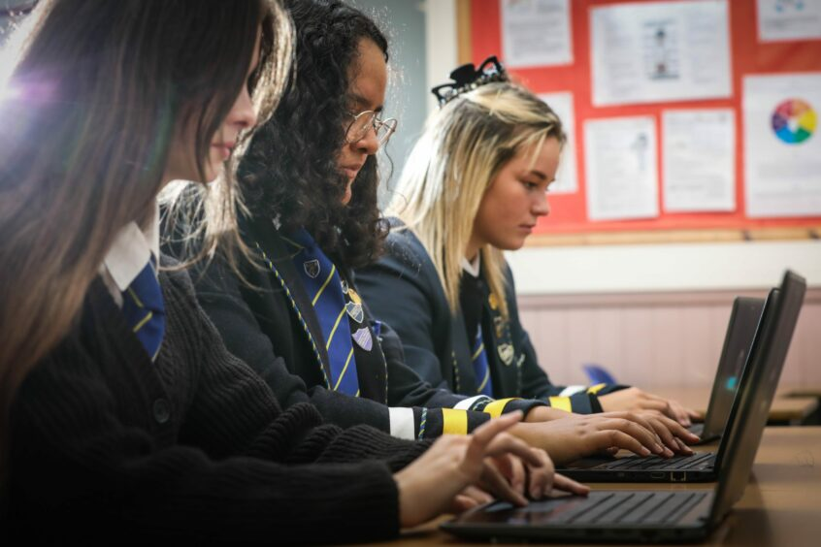
The Morgan Connects programme will see all Morgan Academy students issued with a personal laptop to help them to achieve their full potential as learners. Image: Mhairi Edwards/DCThomson
Are students able to keep their laptops?
Through the Morgan Connects programme, all 951 pupils will be given a laptop and each year new arrivals will be given a laptop as they start S1.
S4 to S6 students have their devices already and those in S1 to S3 will receive theirs by mid-November.
When they leave, students have the choice to keep their device or donate it to the school.
It is expected other schools will follow Morgan’s lead, in line with the government’s pledge to provide a device for every schoolchild during this parliamentary term.
We spoke to some Morgan pupils to find out how having their own laptop has made a difference with their studies.
S6 student Beth Skelly, 17, who is studying for Advanced Highers, said: “It’s really good because during your study periods you can use your laptop in class instead of having to go to the library and have to wait to use a computer there.
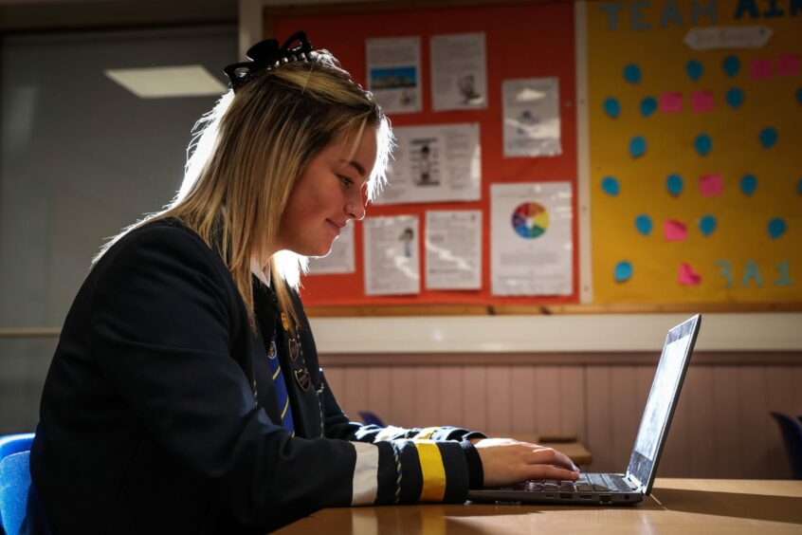
Morgan Academy S6 student Beth Skelly on her laptop. Image: Mhairi Edwards/DCThomson.
“Before, I had no access to a laptop at home so I had to put time into my studies working in the school library after the school day had finished.
“It is much easier to work at home now as I have my own laptop to use.”
The laptops offer students more flexibility
Kaja Przepiora, 17, who is also in S6 and studying various subjects including biology and chemistry, said having her own laptop allows her to work more effectively in school, particularly during study periods.
It also gives her more flexibility, allowing her to work from from any classroom, as well as at home.
While S6 student Indea Adeyosoye, 16, who is studying photography, said: “Having my own laptop has allowed me to work in normal class time as before I would have had to go to the library to use a computer.
“The programme is really beneficial for students as not everyone can afford their own laptop or always get access to a computer in school because times get booked up and they aren’t always available.”
Morgan Academy student Indea Adeyosoye
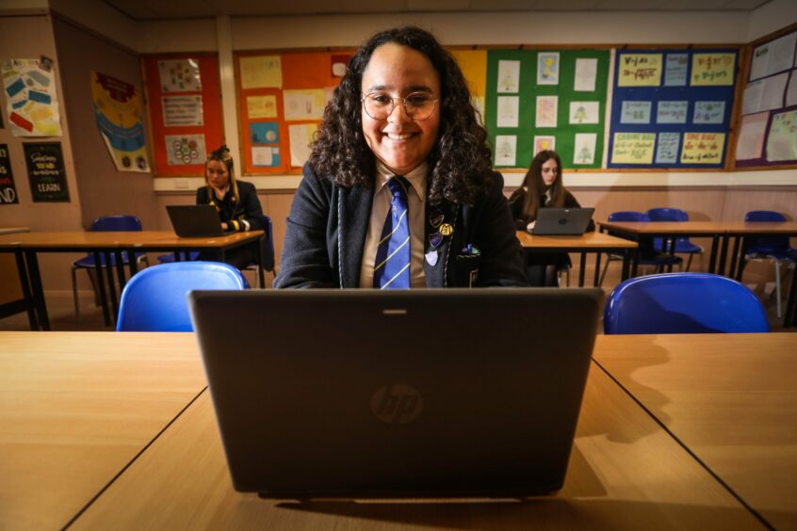
Morgan Academy student Indea Adeyosoye has found having her own laptop has been very beneficial in her studies. Image: Mhairi Edwards/DCThomson
“The programme is really beneficial for students as not everyone can afford their own laptop or always get access to a computer in school because times get booked up and they aren’t always available.”
She added: “It is good being able to keep your laptop because the school is helping you with further education and is continuing to support you which is really nice.”
Johnny Lothian, head teacher at Morgan Academy, said the programme aided the school’s work to raise attainment and reduce the learning gap between its most and least disadvantaged pupils.
He said: “This is a hugely ambitious programme that has taken significant levels of investment and much planning and we believe it is a foundation upon which we can continue to develop and deliver excellent outcomes for our young people.
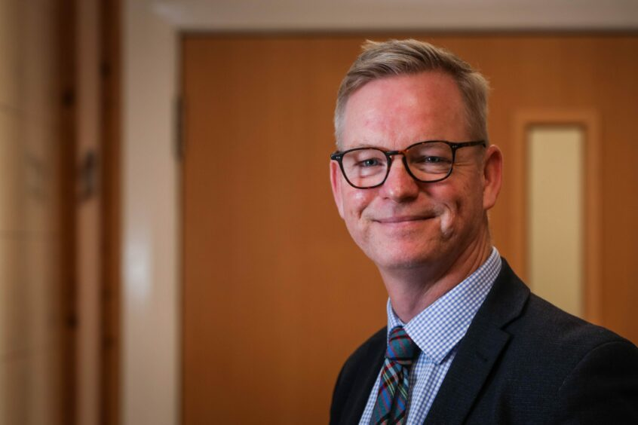
Morgan Academy head teacher Johnny Lothian. Image: Mhairi Edwards/DCThomson.
“Our vision is to become a digital school in which everybody has the skills, connectivity and devices required to reap the benefits of technology for learning, life and work.”
How were the laptops paid for?
Morgan Connects is funded by a combination of the school’s Pupil Equity Funding from the Scottish Government and contributions from school partners including the Morgan Academy Former Pupil Association.
Paul Fleming, chief education officer for Dundee City Council, said he was delighted Morgan Connects is ready for launch and added: “This strategy will also help ensure that all young people at Morgan develop general and specialist digital skills which are vital for learning, life and work in an increasingly digital world.”

