Proms in pictures: Morgan Academy Class of 2022
By Cheryl Peebles
The Courier - June 18 2022, 10.46am
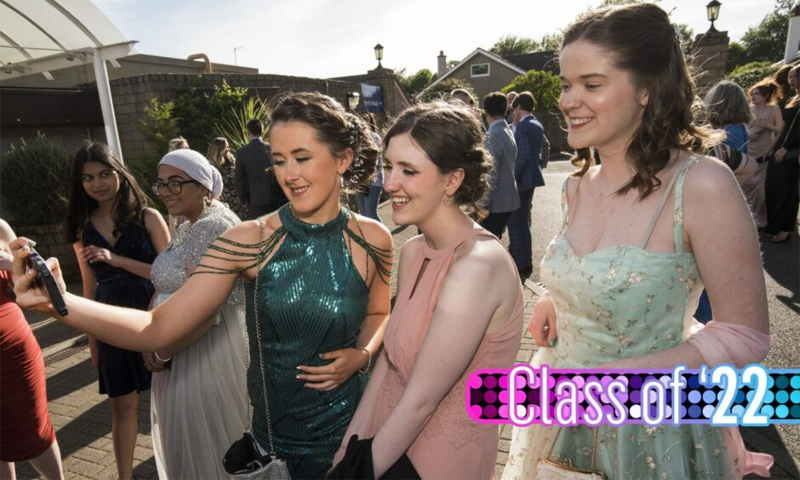
Morgan Academy prom 2022. Pictures by Alan Richardson.
Get the latest from our Schools and Family team straight into your inbox
News, analysis and helpful tips for you and your family

Email address SIGN UP

School prom is a special moment in the lives of young people as they prepare to embark on the next chapter of their lives.
And we were there to witness the rite of passage when it was the turn of Morgan Academy’s Class of ’22 on Friday night.
Classmates gathered to celebrate finishing exams in Dundee’s Invercarse Hotel and to say farewell to friends they had grown up with before moving on to university, college, work or elsewhere.
Dressed to the nines in outfits many had been planning for weeks they arrived in style for a night never to be forgotten.
And as they enjoyed one last hurrah with school chums, our snapper captured the special occasion.
Morgan Academy‘s event is featured in our Class of ’22 series, in which we are showcasing pictures from some of the leavers proms and dances for secondary schools across Tayside and Fife.
Morgan Academy prom 2022:
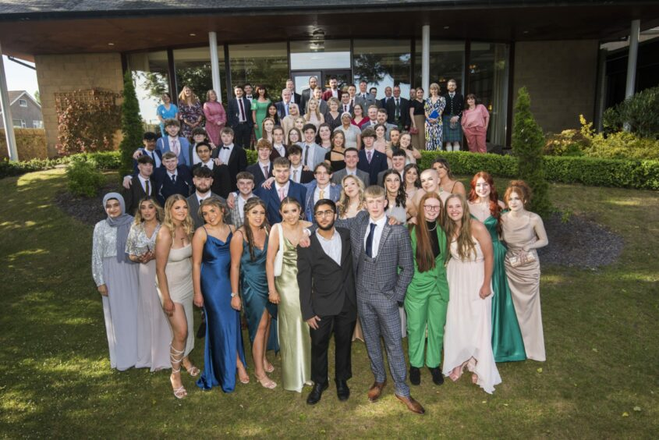
The school leavers with their teachers outside the Invercarse Hotel. Alan Richardson
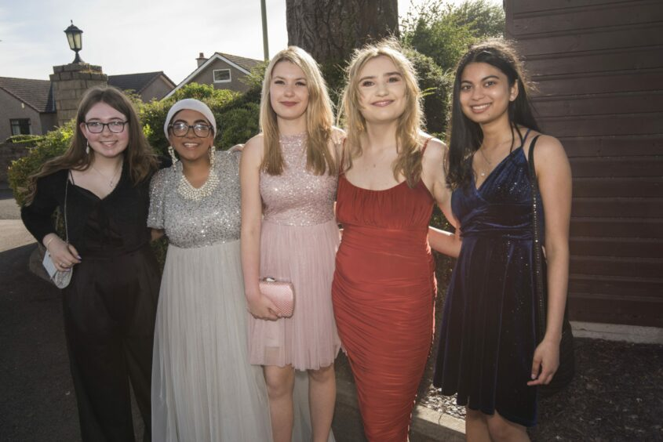
Ready to party (l-r) Lucy Duncan, Fatima Ishaq, Oliwia Szychulska, Megan White and Marylou Silva from Morgan Academy. Alan Richardson
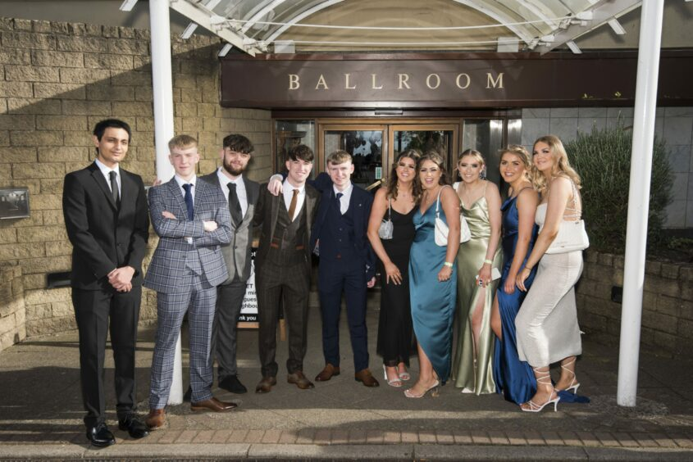
Looking forward to the night (l-r) Mohsin Hussain, Scott Meldrum, Brandon Henderson, Angus Dewar, Blane Devaney, Lucy Innes, Rachel Bain, Lily Fyall, Eilidh Hynes and Holly Clark. Alan Richardson
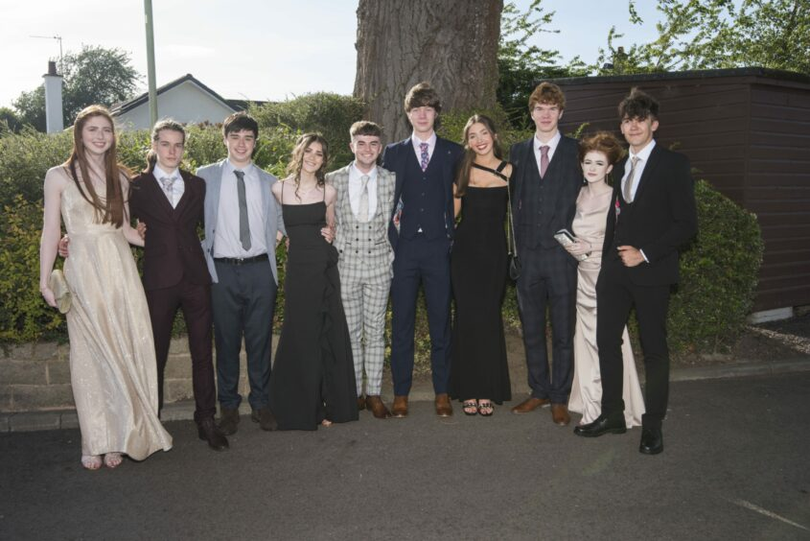
Party time! (l-r) Isla McDougall, James Boswell, Ryan Dolby, Lucy Davidson, Andrew Ross, Sandy Sieigh, Calissa King, May Thomson, Bobbie Ross and Thomas Hunter. Alan Richardson
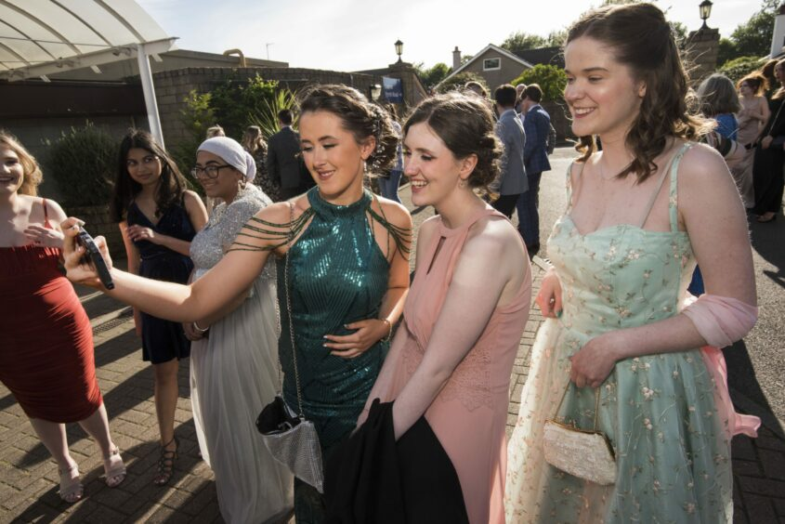
Selfie time for Amber Christie, Eryn Alexander and Katie Close. Alan Richardson
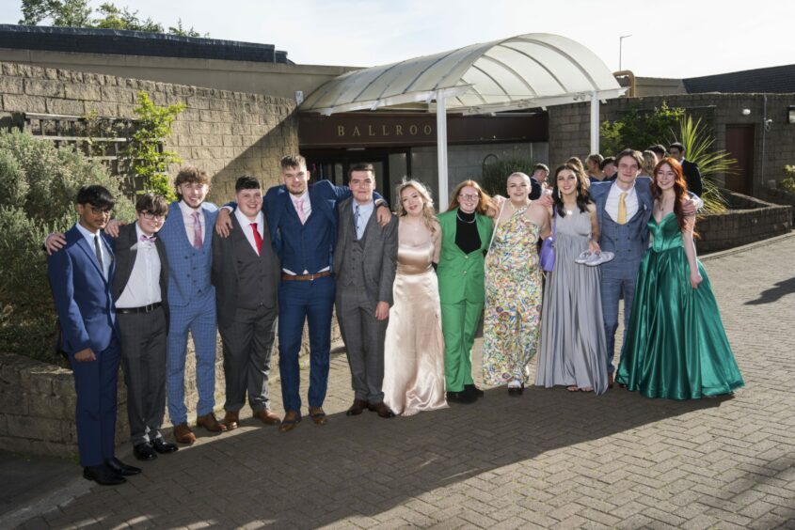
Looking glam! (l-r) Harento Repon, Dylan Hay, Charlie Castle, Tom Lyons, Matthew Pratt, Lennon Doran, Nicole Edelston, Rosie Lloyd, Eris Anderson, Chelsea Elliot, Connor Telfer and Grace Creegan. Alan Richardson

