Oor Fierce Girls: Looking for the next generation of Dundee teenagers to tackle peer sex abuse
By Cheryl Peebles
Dundee Courier - June 20 2022, 5.55pm
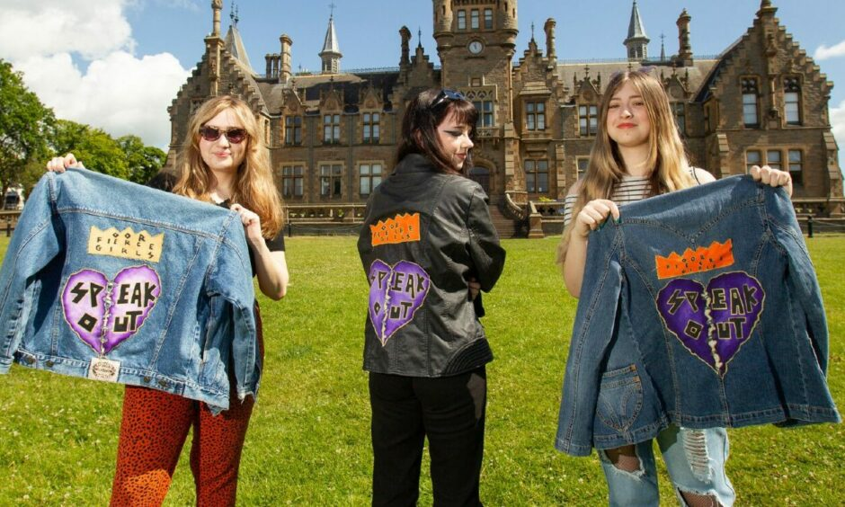
Oor Fierce Girls Megan Whyte, Sophie Kelly and Ashley Henderson. Pictures by Paul Reid.
Get the latest from our Schools and Family team straight into your inbox
News, analysis and helpful tips for you and your family

Email address SIGN UP

Oor Fierce Girls are a band of courageous young women helping peers in Dundee schools speak out about sex abuse and toxic relationships.
But as the schoolgirls who have led the movement prepare to start university, they are recruiting the next generation of girls and young women to take up the cause.
They also hope that schools in other areas will soon have their own Fierce Girls – with talks already underway with authorities in Angus and Perth and Kinross.
As they prepare to pass on the baton, some of Dundee’s Oor Fierce Girls told us about the work they’ve done and what it’s been like being part of the project with Dundee City Council, NSPCC Scotland and YCWA Scotland.
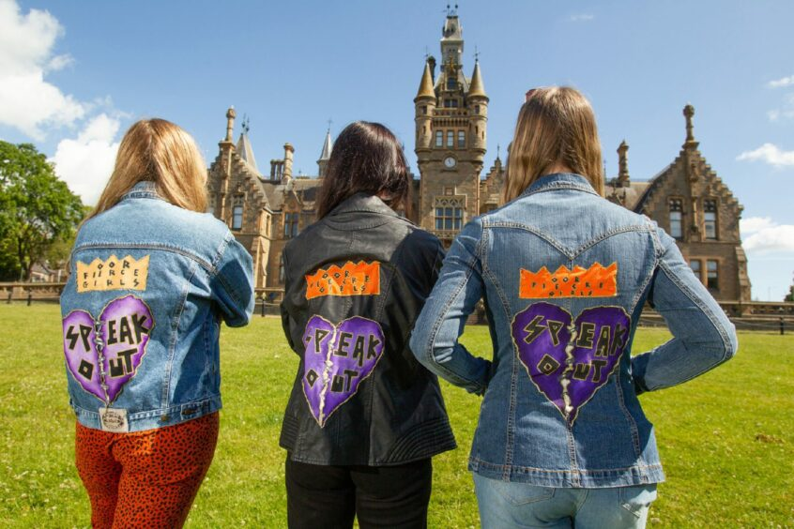
A new logo was designed for Oor Fierce Girls by Sophie Kelly (centre), of Baldragon Academy, pictured with Megan Whyte (left) and Ashley Henderson.
This time last year, the campaign launched a ‘toolkit’ of resources to help professionals and parents talk with young people about peer sex abuse and what a healthy relationship looks like.
The girls were involved with creating the toolkit and have spent the last year raising awareness and ensuring girls and young women know where to go to seek support.
That work has involved media interviews, school tours, recording podcasts including The Guilty Feminist, giving a speech at a demonstration against gender-based violence outside the V&A Dundee and speaking at the NSPCC children’s charity conference.
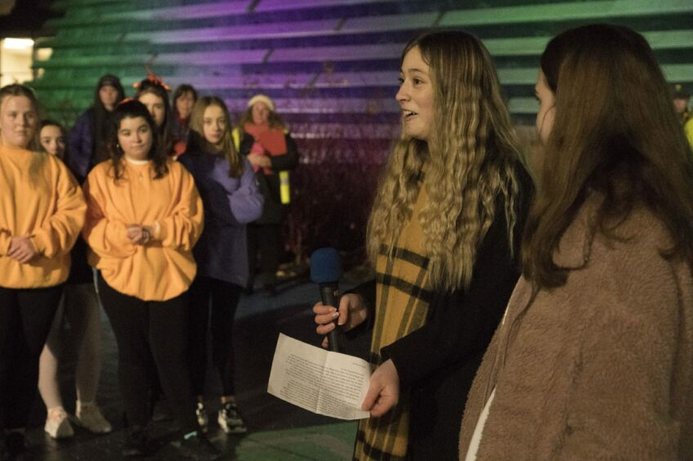
Ashley Henderson at the 16 Days vigil against gender-based violence outside V&A Dundee. Picture by Alan Richardson Pix-AR.co.uk.
Four Dundee schools now have Oor Fierce Girls representatives – Morgan Academy, Baldragon Academy, Craigie High School and Braeview Academy – and it’s hoped an army of new Oor Fierce Girls will march it out to the others next term.
Fatima Ishaq, of Morgan Academy, explained: “Our school signed up to be a ‘test of change’ using our campaign toolkits so we created safe spaces.
We don’t want to sit around and wait for other people to make the change. We are going to make the change ourselves.”
Ashley Henderson
“But we recognised that safe spaces don’t have to be an actual place, and in some schools that’s not readily available, so we delivered staff training using our toolkit and now we have teachers who are the safe spaces young people can go to.”
Fellow Morgan Academy leaver Megan White said: “Teachers are now more willing to speak about things and have more conversations, which is the whole reason behind this campaign.”
The campaign has encouraged more girls to talk about relationships and abusive behaviour, according to Ashley Henderson, of Baldragon Academy.
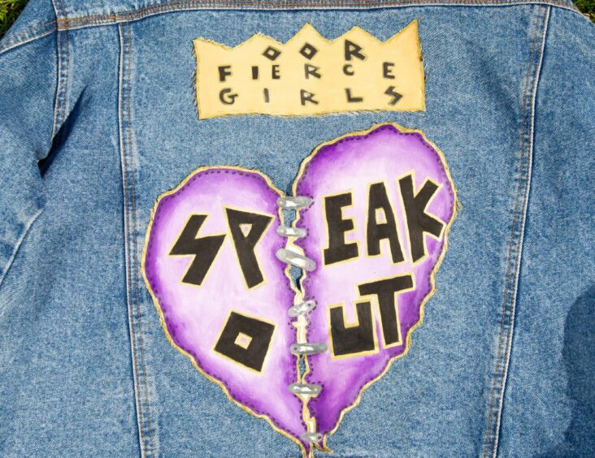
Oor Fierce Girl Sophie Kelly, soon to be a Duncan of Jordanstone College of Art and Design student, designed a new logo for the group.
She said: “Girls I’ve spoken to who know what I do have said they feel more comfortable speaking about this.
“It has taken away some of the stigma around these conversations which is a really positive change.”
And there is a ‘huge’ need for such change, she said.
‘Amazing experience’
“Nobody really talks about the relationship side of things. They talk about sexual abuse and sexual assault but never when it’s with someone you know and love and that can be just as dangerous and just as scary.”
Ashley, Megan, Fatima and Sophie Kelly, who designed the team’s new logo, are moving on to university and art college after the holidays but Ashley said being part of the Oor Fierce Girls had been an “amazing experience”.
She said: “I didn’t expect I’d be doing something like this when I signed up for it. We’ve done press events, podcasts, it’s been incredible.”
They have worked closely with education support officer Sarah Anderson.
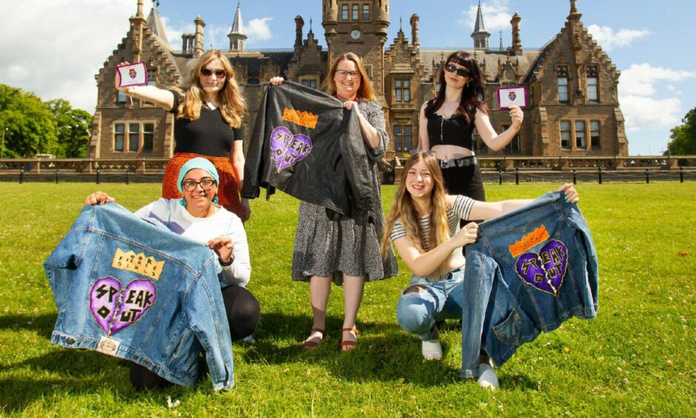
Oor Fierce Girls (from left) Fatima Ishaq, Megan White, Ashley Henderson and Sophie Kelly with (centre) education support officer Sarah Anderson.
Sarah said: “What’s really powerful about the campaign is it’s from a young person’s perspective.
“It’s our young women using their voice and their power to encourage adults around them to listen to things from their perspective and that’s something that’s really hit home, not just for our young people but for adults and particularly for staff that I work with in school.
“But these girls are all off on big adventures next year so we need our next group to come in and carry on their good work.”
The current Oor Fierce Girls have been appealing to younger peers in schools to get involved – and Ashley reckons there will be plenty of interest.
She said: “That’s the thing with our generation. We don’t want to sit around and wait for other people to make the change. We are going to make the change ourselves.”
And it’s vital that that change continues.
Changing attitudes
Sarah said: “All of our data tells us that in Dundee, as in every other authority and school in Scotland, sexual harassment is an issue.
“Sometimes it’s about people of my generation changing our perception around what sexual harassment is.
“For people my age there would have been behaviour that would have been accepted because ‘boys will be boys’.
“But I think very much that attitude that has changed, and rightly so.
“What I’m really proud of in Dundee is that we are being proactive about this and solution-focussed to make things better for our young people and hopefully that’s something we can share with young people in other areas of Scotland.”
Talks are also taking place with the NHS and Police Scotland to create a similar group for boys and young men but its focus is yet to be determined.

