Morgan Academy teacher has her head shaved for Children in Need
By Debbie Clarke
The Courier - November 21 2022, 11.47am
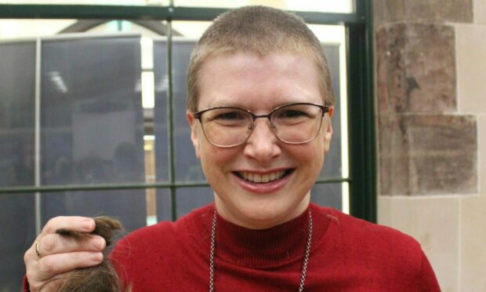
Diane Anderson, English PT at Morgan Academy, agreed to have her head shaved for Children In Need. Image: Supplied by Morgan Academy.
Get the latest from our Schools and Family team straight into your inbox
News, analysis and helpful tips for you and your family

Email address SIGN UP

Morgan Academy teacher Diane Anderson has had her hair shaved off to raise more than £1,200 for Children in Need.
Diane, who is principal teacher of English at the Dundee school, had her hair cut in front of cheering pupils in the school hall.
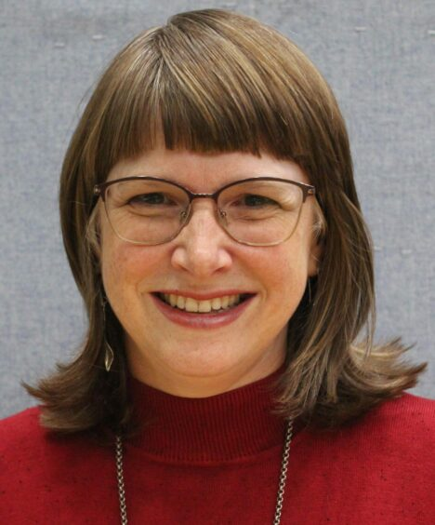
Diane Anderson, PT of English at Morgan Academy, before having her hair cut for Children In Need. Image: Supplied by Morgan Academy.
She hoped to collect £500 but has more than doubled that figure with her fundraising total currently at £1,285.
Fundraising head shave for Children in Need
Diane revealed how she was ‘persuaded’ to have her locks shaved off for a worthy cause.
She said: “A group of S6 pupils approached me and asked if I would consider having a buzz cut done for Children in Need to help their fundraising.
“I felt it was an easy thing I could do to support them and the good causes that will benefit.”
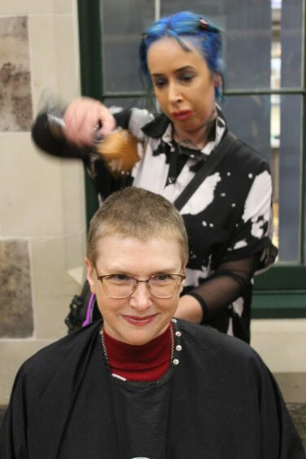
Diane having her head shaved for Children in Need. Image: Supplied by Morgan Academy.
She continued: “To be honest, I was very proud of their persuasive skills.
“Having given it some thought, I decided that life is short and I would regret not taking the opportunity – more than I would regret being bald.”
A hairdresser from Diane’s regular hair salon, Charlie Taylor Hair and Beauty, agreed to perform the cut.
Staff and pupils ‘cheering and applauding’
Diane said she was really pleased to be able do something to help Children In Need.
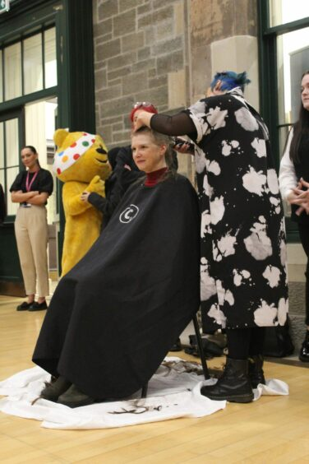
Diane Anderson helping Children in Need. Image: Supplied by Morgan Academy.
“It felt great. The hall was full of bairns and staff cheering and applauding!
“I set up a Just Giving page (which closes on November 30) and my target was £500.
“I did not share the page with pupils, just with friends, family, colleagues, and followers on Twitter.
“But some pupils have sought it out and given money.”
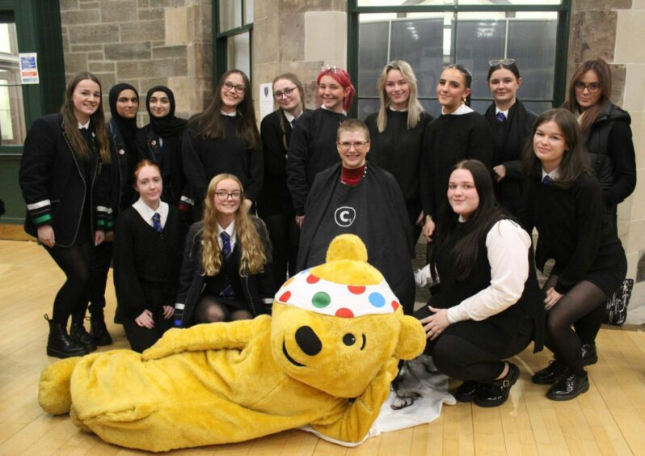
Diane Anderson with pupils after her fundraising haircut for Children in Need at Morgan Academy. Image: Supplied by Morgan Academy.
She added: “I know this money will go to help many children who really need it and I am delighted.”

