Why has Morgan Academy’s lawn been dug up? There’s a blooming good reason
By Cheryl Peebles
Dundee Courier - May 25 2022, 6.00am
Schoolchildren are creating a wildflower meadow at Morgan Academy.
Get the latest from our Schools and Family team straight into your inbox
News, analysis and helpful tips for you and your family

Email address SIGN UP

If you’ve passed Morgan Academy recently you may have wondered why its previously pristine lawn is now a patch of mud.
But you’ll be reassured to know that it won’t be barren for long – it will soon be bursting with wildflowers including poppies, red campion and sunflowers.
Pupils from the secondary school and associated primary schools sowed seeds to create a wildflower meadow in front of the iconic school, one of Dundee’s best-loved buildings.
It’s one of a chain of wildflower meadows being created across the city with the Eden Project, which is bringing a major visitor attraction in the city.
Come July, it’s hoped the spot at the corner of Pitkerro Road and Forfar Road will become a riot of colour – returning annually for many summers to come.
A sowing afternoon was held last Friday. Pictures supplied.
With native species also including corn chamomile, corn flower, scentless mayweed, oxeye daisy and meadow buttercup, the biodiverse meadow will be both eye-catching and a rich habitat for pollinators and other species.
After the triangular plot was ploughed pupils were joined by Eden Project representatives to sow last Friday.
Morgan Academy head teacher Johnny Lothian said: “We are in the business of learning at Morgan Academy, and we believe that nature has much to teach us about how we can live with environment and sustainably in mind.
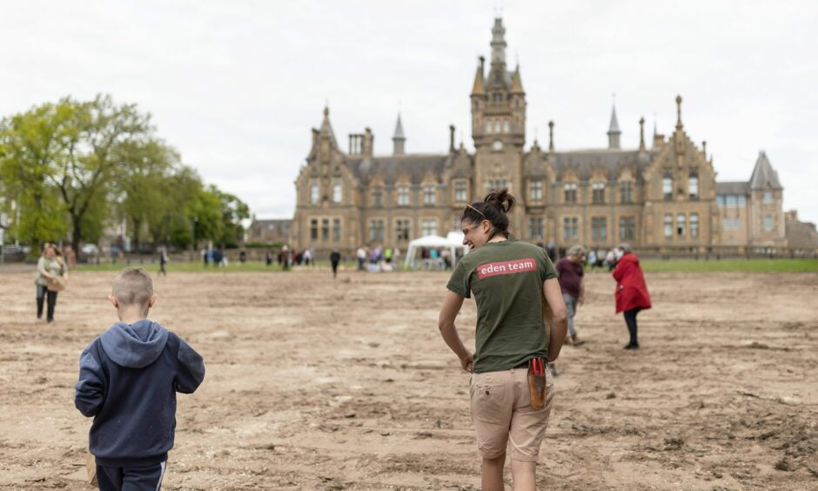
The school worked with the Eden Project to transform its lawn.
“The meadow will provide students with multiple opportunities to learn about nature and biodiversity and will provide our young people with a valuable opportunity to work with partner agencies and with real life data to better understand our natural environment and its needs.”
As well as becoming a colourful focal point helping to generate a sense of environmental pride, Mr Lothian hopes the meadow will boost connections between the school, Stobswell community and natural environment.
He said: “Increasing the biodiversity in the spaces around us is a great way to open the conversation and create deeper connections to nature.”
The meadow will be cut back over the winter to allow space and light for new wildflower seeds to germinate.
Planting was funded by Dundee-based charity the Alexander Moncur Trust.
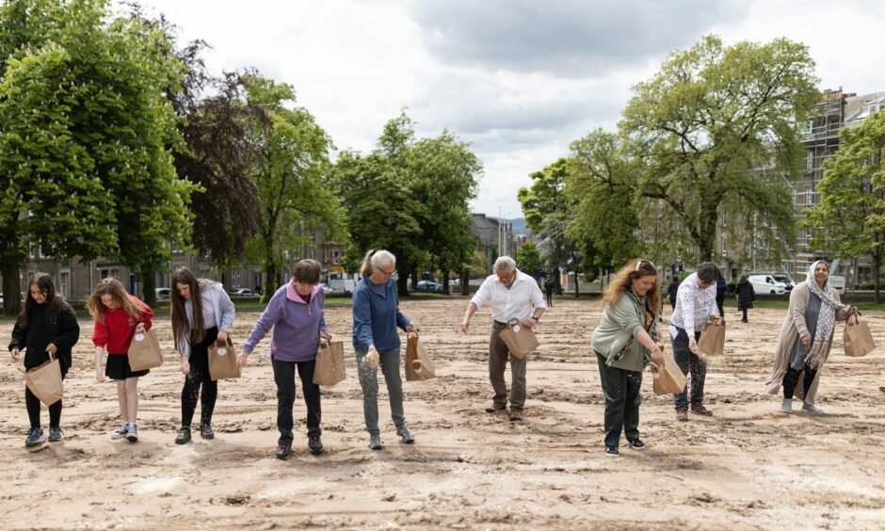
The meadow should bloom come July.

