Hear the spellbinding performance of Dundee’s young musician of the year Morgan Academy pupil Ryan Dolby
By Cheryl Peebles
The Courier - May 6 2022, 5.59am

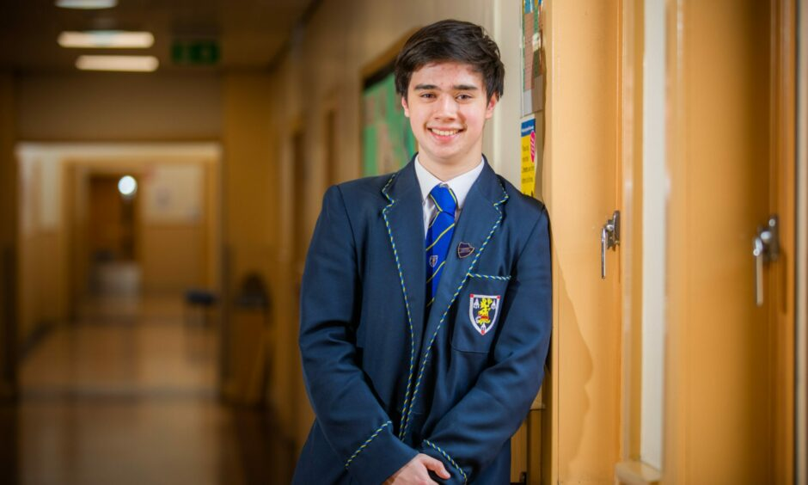
Ryan Dolby, of Morgan Academy, is the Scottish Young Musician Dundee finalist. Pictures: Steve MacDougall/DCT Media.
Get the latest from our Schools and Family team straight into your inbox
News, analysis and helpful tips for you and your family

Email address SIGN UP

This is the performance that made Morgan Academy pupil Ryan Dolby Dundee’s young musician of the year.
And the pianist hopes to repeat his success in front of classical violinist Nicola Benedetti later this month to be named the best in Scotland.
S6 pupil Ryan played Chopin’s Nocturne in Bb and Gennady Lukinykh’s Surf Rumba to win the Dundee final of Scottish Young Musician.
Ryan was among 17 young musicians in the Dundee final of Scottish Young Musician held at Harris Academy.
He will compete against the other regional winners in the national final in the Royal Conservatoire of Scotland, Glasgow, on May 29.
They include the Angus, Fife and Perthshire winners Noah Chalamanda, Robbie Dowall and Stephen Ip.
Kirstin Brown, the school’s principal teacher of music, drama and physics, said: “We are hugely proud of what Ryan has achieved and look forward to hearing him in the Scottish finals.
“It is a real pleasure to have performance opportunities that give our talented young people the platform to showcase their skills.”
The final
As he prepares for the national final, Ryan will be the first performer to use the school’s Tom Hermiston piano, funded by Morgan Academy Former Pupils Association in memory of the former teacher.
He will be competing in the solo performer title in the contest being run for the first time by those behind the well-established North Ayrshire Young Musician Competition.
The brass ensemble of the year competition, which was held online, has already been won by Perth High School Brass Ensemble.
Every young person learning to sing or play an instrument in a school in Scotland was able to enter.
The overall winner will have the chance to work, play and learn with world-class musicians with links to music colleges for future consideration of a career in music

