Watch: Gold Leng Medal winner Archie sings a traditional Scots song to us for Burns Day
By Sheanne Mulholland
The Courier - January 25 2023, 6.00am

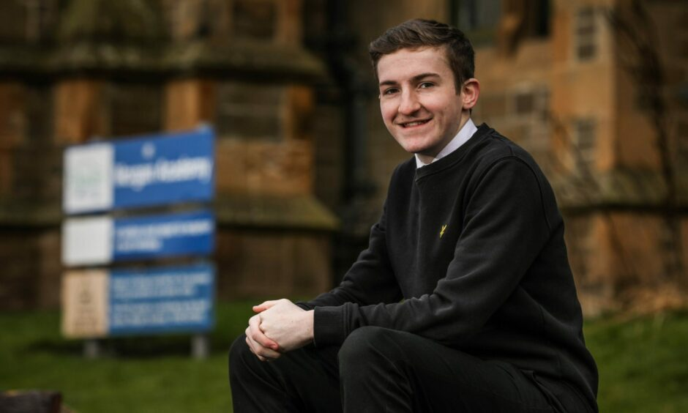
Archie Turnbull outside Morgan Academy before singing us a Scots language song. Image: Mhairi Edwards/DC Thomson.
Get the latest from our Schools and Family team straight into your inbox
News, analysis and helpful tips for you and your family

Email address SIGN UP

Most of us associate Burns Day with a haggis dinner, a few recitals of our national bard’s poems and perhaps a wee dram for the adults.
Children at many schools across Tayside and Fife have been busy learning Robert Burns poems and other Scottish language poems ahead of today.
But in Dundee, many senior pupils are keeping Scots alive by singing traditional songs in the language.
In the spirit of the day, and in tribute to our national heritage, we asked young singer Archie Turnbull to treat us to a Scottish song.
And the 14-year-old pupil at Morgan Academy, Dundee, stunned us with his performance of The Bonny Ship the Diamond.
Archie, who has a background in musical theatre, said: “I like singing in Scots language because I’m used to different kinds of styles of songs.”
The S3 pupil said he often sings American songs, which have a “twang” to them, so he finds comfort in singing songs with more familiar words and a natural fit to his own accent.
He added: “I think it’s important the Scots language is kept alive because it’s not really that prominently spoken in Scotland anymore – they still speak it in the Highlands.
“And I think it’s important because it keeps us attached to our culture that our ancestors once used.”
Champion singer
Archie is no stranger to performing in Scots – he won the gold Leng Medal last year with this song.
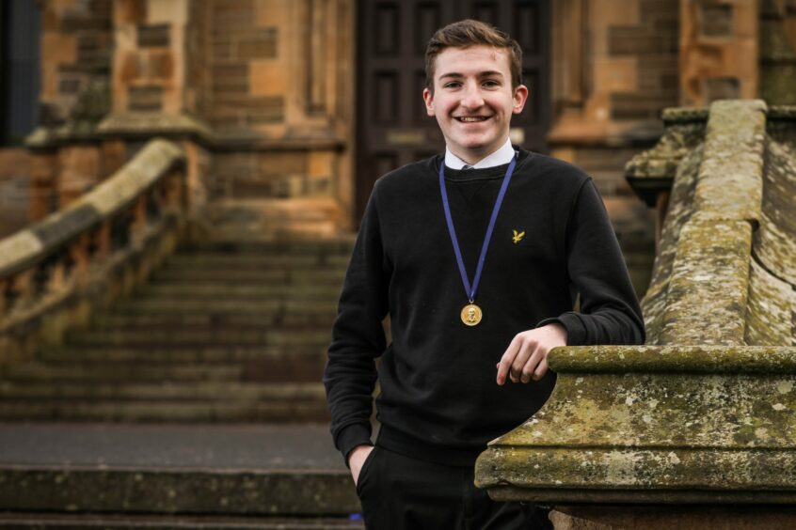
Morgan Academy pupil Archie Turnbull with his Gold Leng Medal. Image: Mhairi Edwards/DC Thomson.
Having bagged the silver medal when he was in P6 at Clepington Primary School, Archie was able to compete at gold level when it returned following a short break due to Covid.
And on his second attempt, Archie was crowned male winner – pipping senior pupils to the post in the process.
He said: “I was very nervy before I sang but I was excited to go up and do it.
“We all had to line up to sing and could see everyone ahead of us performing. Then when we finished our song we went and sat down, and watched everyone else take part.
“After singing I thought ‘that went well’ and I was shaking when I sat down.
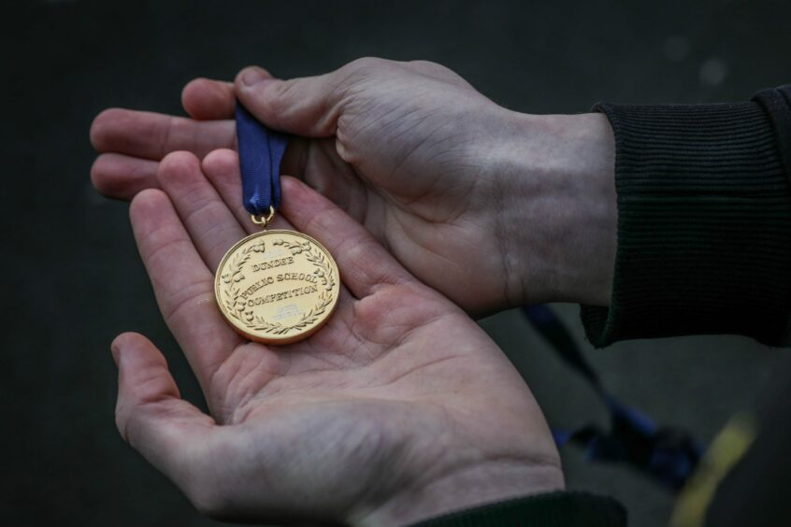
Archie’s gold Leng Medal. Image: Mhairi Edwards/DC Thomson.
“I was completely surprised when they said I had won – overwhelmed, I couldn’t believe it. It was only when I got the medal that it sunk in.”
The Leng Medal is organised by the Sir John Leng Trust, which has been on the go for more than 100 years.
The singing competition aims to encourage and promote the teaching of the songs of Scotland.
Primary school pupils compete within their own school for the silver medal, then silver medal winners compete against each other for the gold medal.
It’s in with the bricks.”
Phil McGregor
Phil McGregor is education support officer for music, performing arts and culture for Dundee City Council and supports the children with learning their songs.
He said: “The competition keeps Scots songs alive, that’s really important, it’s the whole ethos – unaccompanied Scottish songs, it’s very traditional.
“It’s a long held tradition in Dundee, it’s in with the bricks. It’s the one singing competition that happens every year.”
This year’s Gold Leng Medal competition takes place on February 22.

