How well do you know Baxter Park? Let these Dundee pupils tell you more
by Laura Devlin
September 28 2021, 6.45pm
Share
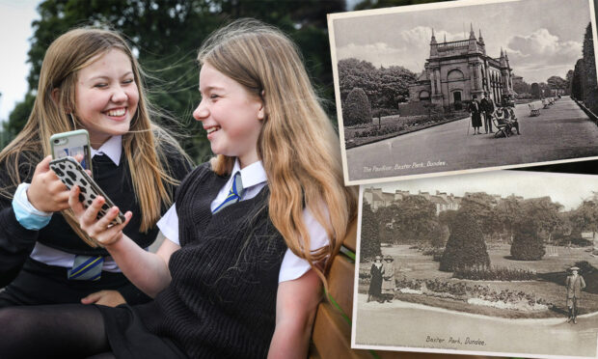
Pupils from Morgan Academy have teamed up with Dundee University's archive services to launch an interactive resource.
Schools newsletter - Reports, analysis and tips to help you and your family.

Email addressSign up

Baxter Park has been an iconic landmark of Dundee for more than 150 years.
But how much of the history behind the so-called People’s Park do Dundonians really know?
To encourage the local community to find out more, pupils from Morgan Academy have teamed up with Dundee University’s archive services to launch an interactive resource.
The pupils have created an audio narrative of the park’s history, stretching from the original planning of the park in the 1860s through to its regeneration and reopening in the 2000s.
This can can accessed via QR codes throughout the park and links back to the Big Back Garden website.
Here, visitors can see the records they used, explore the park through a quiz trail and post their memories and stories on the comments page.
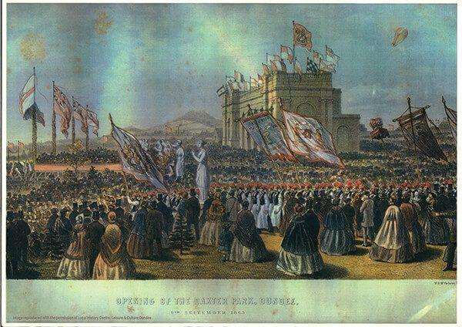
An image depicting the opening of Baxter Park in 1863. Supplied by the University of Dundee archive services via the Big Back Garden website.
An interactive resource
Head of history at Morgan Academy, Annabel Quin, has helped with the project, which was first mooted in 2018 and has taken almost two years to come to come to fruition.
She said: “We thought (the project) would best fit in with our S3 curriculum. There’s a real push on looking at local history, thinking about it’s importance and its cultural heritage.
“We had a number of meetings and we managed to get Dr Jan Merchant (senior archivist at Dundee University) in to do a presentation to pupils about the history of the park.
“The next stage was to get pupils engaging with the archive materials over a number of weeks.
“Working in groups, they were assigned a particular area of focus or point in time and they created their narrative for that.”
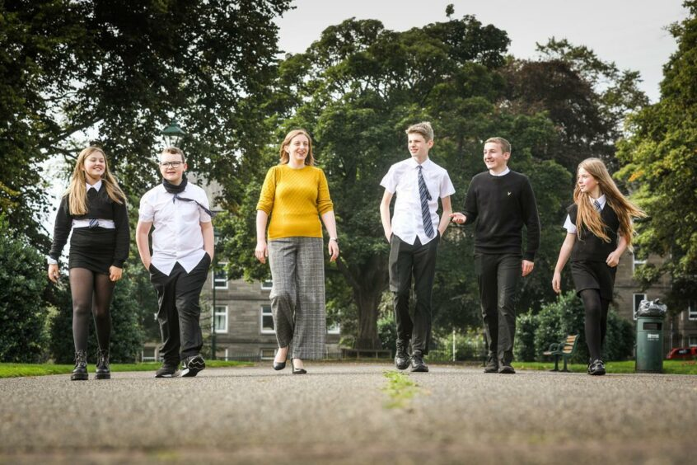
History teacher Annabel Quin with pupils Grace Harris, Finlay Hornby, Max Langford, Archie Turnbull and Olivia Adams.
Like many things, the project was disrupted by the Covid-19 pandemic and by the time schools returned to in-person teaching, some of the original pupils involved had moved on.
This allowed for first year pupils to get involved, and a select few were given the opportunity to help record the audio narration.
Ms Quin said: “We set aside a a whole day and they worked with a sound engineer to record the narratives.
“We also did a lot of outdoor learning at the park, getting them to think about how it could link to leadership and career opportunities.
“We got them to imagine that they were creating an outdoor museum, so where would they put the locations, how would they create a workable trail. They did a really great job.”
“It was a great experience”
Among the pupils involved in recording the audio narration were S2 pupils Finlay Hornby and Archie Turnbull.
Archie said: “We got asked by our teacher if we wanted to get involved with the project and we got a script of the research of Baxter Park’s history.
“We found out about the foundation of the park and we found this information really interesting.
“It was nerve wracking at first but we were excited to be participating in it. It was a great experience.”
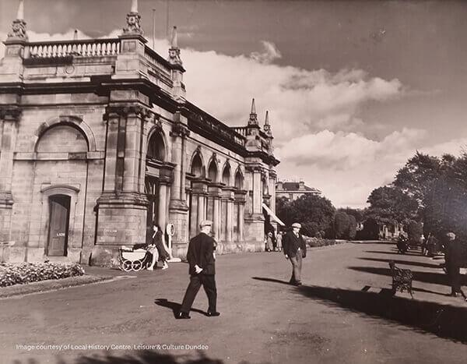
Baxter Park C1950s. Supplied by Big Back Garden Project via Leisure and Culture Dundee.
Finlay added: “We’ve found out about our local park’s history and we didn’t know half the things about it before. That’s made it more interesting because it’s local.
Also involved were Grace Harris and Olivia Adam, both in S2, who enjoyed the recording process and the chance to try something different.
Grace said: “I had read two scripts so it took a bit longer for me, but it was fun to miss out on lessons!”
Park has “long history” and “strong identity”
Dr Jan Merchant, senior archivist at Dundee University, said: “The park still plays a central role within the community, especially since its regeneration and re-opening in 2007.
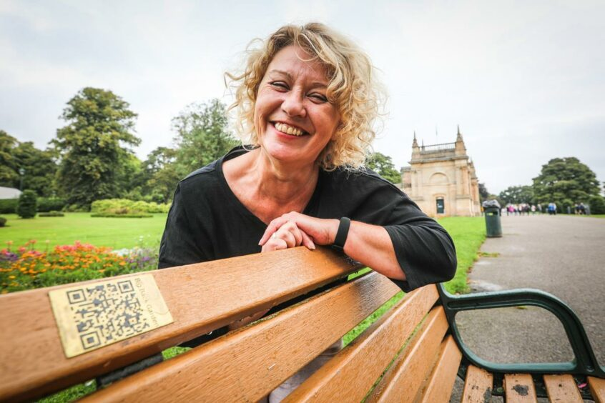
Dr Jan Merchant.
“The research of original source material by Morgan Academy’s S3 history classes is central to the Big Back Garden project.
“Baxter Park has a long history and a strong identity, one that is enhanced by the stories based on the pupils’ research. Through the BBG project, these can be built on and developed.”

