Creating a school meadow has brought us closer to nature

The Eden Project helped one Scottish school sow a wildflower meadow in its grounds – and it has become far more than just a colourful focal point, explains headteacher Johnny Lothian

TES 14th April 2023, 6:00am

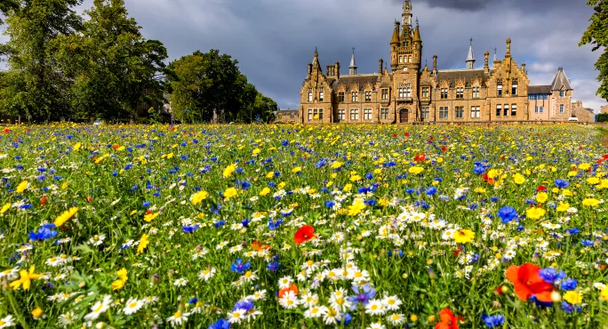

It is a very exciting time to be a leader of learning in Dundee. The city is simultaneously connected to its rich industrial history and looking forwards to a bright future - a future built around design, innovation, life sciences and digital technology. With these many developments at the city level, there are opportunities for schools to work creatively and innovatively in partnership approaches to curriculum design.

The establishment of the new Eden Project Dundee in 2025 will be transformative for the city, drawing on its rich history and playing an important role in the regeneration of the Dundee waterfront. The proposed world-class visitor attraction and experience will be situated on the site of the former Dundee Gasworks on the bank of the River Tay, a short walk from our learning community, Morgan Academy.

Effective school leaders recognise that partnership is essential to any aspirational vision of curriculum. Our curriculum is richer when we don’t go it alone. Community collaboration in the design and delivery of experiences and outcomes - with and for learners - allows creativity and innovation to bloom. We also know from experience that a curriculum built around the uniqueness of our own space, setting and context can provide meaning and relevance and can generate pride and purpose within learners.

So when an opportunity arose for staff and learners to work in partnership with Eden on a project to repurpose the Morgan Academy school lawn and create a biodiverse wildflower meadow, we grabbed it with both hands. Following a very positive period of community consultation, members of our learning community and local partners prepared and sowed the site in May 2022, with the meadow blooming in the summer months that followed.
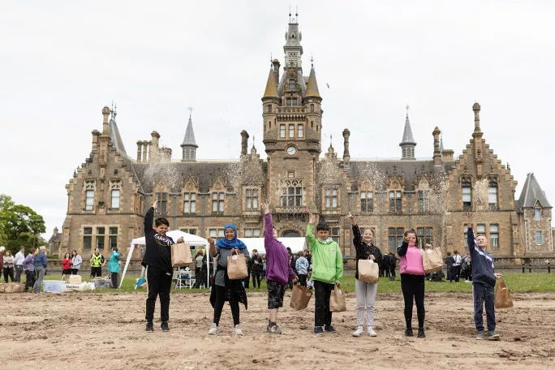

We wished to create a colourful focal point for our school community, believing that this new habitat could help to generate pride in our school environment and provide a connection between our local community and the natural world.

One year into the project, the school now sees the meadow as an important community asset. It has been a focal point and a source of great pride for learners, staff, parents and local residents alike. Local artists and photographers have used the space as a stimulus for their work. It has very much become part of our school’s uniqueness. Part of our story.

Until recently, the school lawn had always been a no-go area for students. Former students of Morgan Academy regularly tell of the severe punishments one could expect from the rector for being caught in the act of “trespassing” on the lawn. Historically, this is a piece of land that hasn’t contributed much to the context of our learning community. This has now changed.

In addition to the aesthetics, this project is of environmental and educational benefit. The creation of the wildflower meadow provides a habitat for important species of pollinators and other wildlife. This is a positive step within the context of the significant reduction in native wildflower habitat s both locally and nationally; the UK having lost 98 per cent of its wildflower habitats since the Second World War.

Learning about the natural habitat

It would be fair to say that due to competing demands over the previous few sessions, developing our whole-school approach to a curriculum for sustainability has not been a priority. The establishment of the meadow was, therefore, of significance both symbolically and as a foundation stone upon which we could build future curriculum development.

We saw this as an important action for our learning community to demonstrate our commitment to a future for our children that has sustainability and care for the environment at its heart. We have found that increasing the biodiversity in the spaces around us is a useful way to open the conversation about environmental stewardship with young people and help to create deeper connections to nature.

The Morgan meadow provides our students with multiple opportunities to learn about nature and biodiversity and to better understand our natural environment and its needs. Curriculum involvement in science has focused on habitat and diversity within the context of this much more diverse landscape, and we have observed an increase in pollinators and other wildlife on campus.

In addition, relevant planned learning experiences from around the wider curriculum grew organically. Within the creative arts and languages curriculum, for example, the meadow has been the focus of learning projects in photography and creative and persuasive writing.

In addition to work with the team at Eden, the project has resulted in increased opportunities to work with community partners. Following harvest, for example, seeds were gifted to other local community organisations, which will use them in their own wildflower projects this spring.

In terms of learning, it is also true that from the seed of the meadow project there are other opportunities germinating for future nature-based curriculum learning. Some examples of this include the establishment of our own school bee colony, the introduction of monitoring equipment that can detect and record bird species in partnership with RSPB, and a separate partnership with the University of Dundee for senior phase students to use DNA sequencing in the classroom in relation to daffodils.

While we had high hopes for the meadow at the outset, the reality has exceeded any expectations.

We hoped this project would create a natural community environment and provide a focus on nature and sustainability, while also strengthening the connection between our community and the natural world. The beautiful Morgan meadow has brought students, teachers and the local community together with a focus on learning with nature, while generating a great deal of community and civic pride in the process. Now there is a sense of anticipation and excitement as we await our meadow coming back to life.

This feels like the early chapters of a story of improved connection, restoration and care of nature within this amazing community and developing city.

Johnny Lothian is the headteacher of Morgan Academy in Dundee. He tweets @JohnnyLothian

Johnny Lothian

