Relationships and Positive Behaviour Management at Morgan Academy

As a Rights Respecting School, we believe positive relationships and behaviour to be integral to achieving a happy, healthy and safe learning community. The Morgan Academy Relationships policy is informed by and closely aligned with the guidance provided in the ‘Getting it Right for Every Child, ‘Trauma Informed Schools’ and the ‘United Nations Convention on the Rights of the Child’ documentation.

As such, our primary aim is to place the child at the centre of all decisions that affect his or her learning so that each individual within our community can be appropriately supported to be:
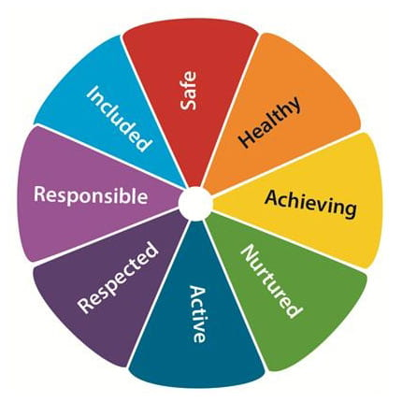

The relationships policy at Morgan Academy has been designed as a means of promoting and enhancing positive relationships for learning. To this end, all interactions are underpinned by the foundational school values; especially those of love, respect and honesty.
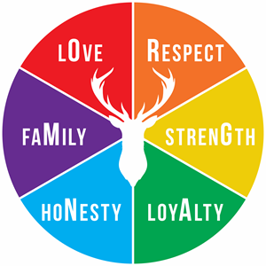

Morgan Academy embraces the Pivotal approach to promote positive relationships and behaviour. In line with the Pivotal approach, there are three Responsibilities that everyone in the Morgan Academy community will aim to adhere to, whether in classrooms, corridors, or the school grounds.
These Responsibilities are Ready, Respectful, Safe.

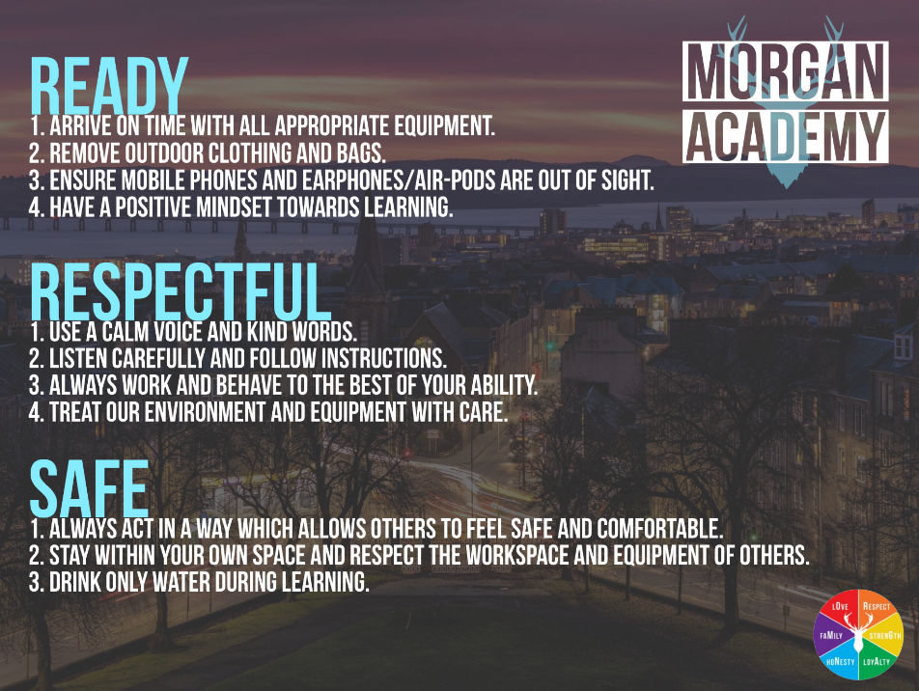

Positive behaviour is formally recognised using school tracking reports, attendance/late-coming statistics, Achievement Postcards and Badges and the awarding of House points. Rewards from these are delivered through House Achievement Assemblies.

The use of praise and promotion of positive behaviour choices is central to good behaviour, but it is recognised that consequences must be implemented in order for pupils to be able to reflect and learn from poor choices.

In line with the ‘Pivotal’ approach to behaviour management, staff will follow a staged approach, with transgressions of the classroom responsibilities dealt with as detailed in the graphic below.

