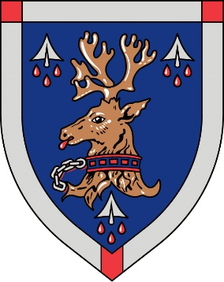
Morgan Academy approach to presentation

Pupils are encouraged to wear full school uniform. It is clear from regular samplings of opinion that almost all parents support this policy. Dressing appropriately is also an important lesson for pupils preparing for a later career and it helps to avoid the highlighting of any differences in background or family circumstances.

Dress Code for students
Morgan Blazer*, Morgan Tie, Snr Tie (S6 only), Dark plain jersey (v or crew neck) or sweatshirt (not branded), White shirt, Dark trousers or skirt, Navy or white socks, or black, navy or natural tights, Black or dark plain footwear.

*The School Blazer is worn by S4-S6 pupils including Prefects. While the School Blazer is not included in the minimum standard of uniform below which pupils should not fall, its use is encouraged.

PE Clothing

The school offers an extensive range of physical activities and appropriate clothing and footwear is essential to ensure the safety and personal hygiene of all concerned.

Indoor Work
• non marking indoor training shoes or gym shoes
• change of socks
• dark shorts (black)
• PE department t-shirt or black t-shirt
• Pupils have the opportunity to purchase a Morgan Academy PE top.

Outdoor Work
• Training shoes or boots suitable for work on grass or synthetic surfaces
• Tracksuit
NB: All items of clothing should be clearly identified with the young person’s name.

